OS Concept: Device Management

By Rathod Raja V.

1. What is Polling ? Explain in brief.
Ans:
1. Polling is also called as Busy-waiting.
2. Assume that 2 bits are used to coordinate the producer–consumer relationship between the controller and the host. The controller indicates its state through the busy bit in the status register.
3. The controller sets the busy bit when it is busy working and clears the busy bit when it is ready to accept the next command.
4. The host signals its wishes via the command-ready bit in the command register. The host sets the command-ready bit when a command is available for the controller to execute.
5. For this example, the host writes output through a port, coordinating with the controller by handshaking as follows.
1. The host repeatedly reads the busy bit until that bit becomes clear.
2. The host sets the write bit in the command register and writes a byte into the data- out register.
3. The host sets the command-ready bit.
4. When the controller notices that the command-ready bit is set, it sets the busy bit.
5. The controller reads the command register and sees the write command. It reads the data out register to get the byte and does the I/O to the device.
6. The controller clears the command-ready bit, clears the error bit in the status register to indicate that the device I/O succeeded, and clears the busy bit to indicate
that it is finished.
6. This loop is repeated for each byte.
7. In step 1, the host is busy-waiting or polling:it is in a loop, reading the status register over and over until the busy bit becomes clear.
8. For instance, when data are streaming in on a serial port or from a keyboard, the small buffer on the controller will overflow and data will be lost if the host waits too long before returning to read the bytes.

2. What is Interrupt ? Explain in brief.
Ans:
1. The hardware mechanism that enables a device to notify the CPU is called an interrupt.
2. The CPU hardware has a wire called the interrupt-request line that the CPU senses after executing every instruction.
3. When the CPU detects that a controller has asserted a signal onv the interrupt-request line, the CPU performs a state save and jumps to the interrupt-handler routine at a fixed address in memory.
4. The interrupt handler determines the cause of the interrupt, performs the necessary processing, performs a state restore, and executes a return from interrupt instruction to return the CPU to the execution state prior to the interrupt.
5. ing a signal on the interrupt request line, the CPU catches the interrupt and dispatches it to the interrupt handler, and the handler clears the interrupt by servicing the device.

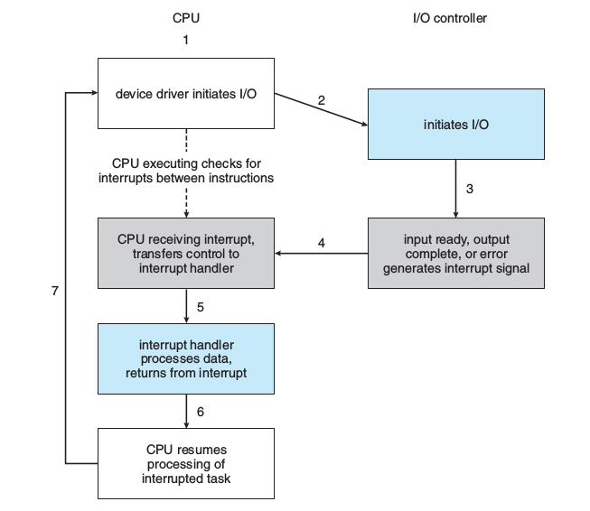
Fig. Interrupt driven I/O

6. The basic interrupt mechanism just described enables the CPU to respond to an asynchronous event, as when a device controller becomes ready for service. In a modern operating system, however, we need more sophisticated interrupt-handling features.
7. Feature of interrupt handling features:
1.We need the ability to defer interrupt handling during critical processing.
2. We need an efficient way to dispatch to the proper interrupt handler for a device without first polling all the devices to see which one raised the interrupt.
3. We need multilevel interrupts, so that the operating system can distinguish between high- and low-priority interrupts and can respond wit the appropriate degree of urgency.
8. Most CPU s have two interrupt request lines. One is the nonmaskable interrupt, which is reserved for events such as unrecoverable memory errors. The second interrupt line is maskable: it can be turned off by the CPU before the execution of critical instruction sequences that must not be interrupted. The maskable interrupt is used by device controllers to request service.

3. What is DMA ? Explain in brief.
Ans:
1. Direct memory access (DMA) is a feature of computer systems that allows certain hardware subsystems to access main system memory (RAM), independent of the central processing unit (CPU).
2.To initiate a DMA transfer, the host writes a DMA command block into memory. This block contains a pointer to the source of a transfer, a pointer to the destination of the transfer, and a count of the number of bytes to be transferred.

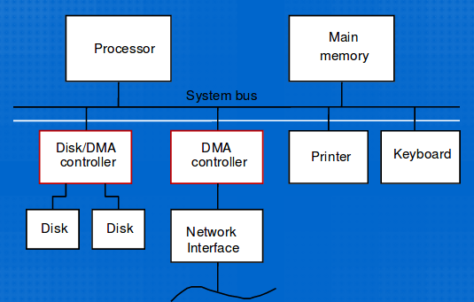

3 .The CPU writes the address of this command block to the DMA controller, then goes on with other work.
4. The DMA controller proceeds to operate the memory bus directly, placing addresses on the bus to perform transfers without the help of the main CPU . A simple DMA controller is a standard component in all modern computers, from smartphones to mainframes.
5. Handshaking between the DMA controller and the device controller is performed via a pair of wires called DMA -request and DMA -acknowledge.
6. The device controller places a signal on the DMA -request wire when a word of data is available for transfer. This signal causes the DMA controller to seize the memory bus, place the desired address on the memory-address wires, and place a signal on the DMA acknowledge wire. When the device controller receives the DMA -acknowledge signal, it transfers the word of data to memory and removes the DMA -request signal.

4. Draw kernel I/O structure.
Ans:
1. The purpose of the device-driver layer is to hide the differences among device controllers from the I/O subsystem of the kernel, much as the I/O system calls encapsulate the behavior of devices in a few generic classes that hide hardware differences from application.
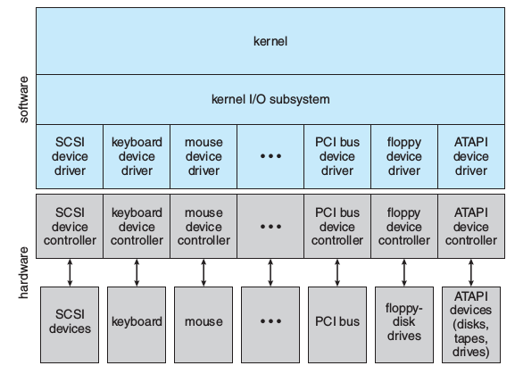
Fig. Kernel I/O Structure

5. Explain Block and Character Device
Ans:
1.A Character ('c') Device is one with which the Driver communicates by sending and receiving single characters (bytes, octets).
2. A Block ('b') Device is one with which the Driver communicates by sending entire blocks of data.
3. Examples for Character Devices: serial ports, parallel ports, sounds cards
4. Examples for Block Devices: hard disks, USB cameras, Disk-On-Key.
5. The block-device interface captures all the aspects necessary for accessing disk drives and other block-oriented devices. The device is expected to understand commands such as read() and write() .
6. If it is a random-access device, it is also expected to have a seek() command to specify which block to transfer next. Applications normally access such a device through a file-system interface. We can see that read() , write() , and seek() capture the essential behaviors of block-storage devices, so that applications are insulated from the low-level differences among those devices.

